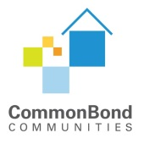
Board Associate Application

Thank you for your interest in the Board Associates Program.

As a Board Associate, you must be able to perform the necessary responsibilities and commit approximately four hours a month for a two-year term beginning in January 1, 2022. Associates will participate in Board business (attend Board and committee meetings, fundraising events, receive all documentation, make financial contribution to CommonBond that is appropriate for them, etc.). A stipend of $2,000 annually will be offered to cover costs to you for your participation.

Please complete and submit this form, along with a resume, to BoardAssociates@commonbond.org by November 30, 2021.

Name:

Email:

Phone number:

Current position

Company/Organization:

Why do you want to be a Board Associate? What do you hope to gain from the experience?

What skills, interests, and life experiences would you bring to CommonBond?

Describe your interest in and any experience you have with affordable housing.

Is there anything else you would like to tell us about yourself?

Do you foresee any career changes that will limit your ability to participate? If yes, please explain:

Do you have any special geographic or transportation needs as it relates to attending board meetings?

